**Pakistan Economic Crisis: A Critical Review**

Kunal Gupta, Sanidhya Negi

6th semester (BCom hons) , Dyal Singh College

1. **Introduction**

Pakistan has a long history of economic instability and has experienced several crises. The current economic crisis is a result of various factors such as a significant trade deficit, an increasing debt burden, and a depreciating currency. These issues have severely impacted the country's development and stability, resulting in high rates of inflation, unemployment, and poverty. COVID-19 pandemic, energy crisis and natural disasters like floods have worsened the economic crisis in Pakistan. The Pakistan government asked for assistance from international organizations like the IMF and the World Bank, implementing austerity measures, and removing subsidies. Despite these efforts, the crisis persists, and the population continues to suffer. Pakistan has been facing an energy crisis for a prolonged period too, which has further contributed to its economic crisis. The energy crisis has resulted in frequent power outages and load shedding, which has adversely impacted businesses and industries, and led to a decline in productivity. This has also affected the country's investment climate and impacts its economic growth. The government has implemented various measures to address the energy crisis, however the crisis persists and remains a significant challenge for the country's economy.

This research paper aims to provide a comprehensive analysis of the root causes of Pakistan's economic crisis and the role of international organizations in addressing it. Furthermore, the study will examine the effects of the crisis on the Pakistani population and its impact on other countries. Finally, the paper will conduct a comparative analysis of Pakistan's economic crisis with other countries that have experienced similar crises.

The study will contribute to the existing literature on economic crises, specifically in developing countries. By understanding the underlying causes of the economic crisis, the research will provide a basis for future decisions that can help in avoiding economic crisis any developing country.

1. **Objectives**

* To analyse the root causes of Pakistan's economic crisis.
* To study the role of international organisations in addressing Pakistan's economic crisis.
* To explore the effects of the economic crisis in Pakistan on its population as well as its impact on other countries.
* To conduct a comparative analysis of Pakistan's economic crisis with the economic crises of other countries.

1. **Keywords**

Pakistan, economic crisis, Inflation, IMF, Corruption, Poverty, Unemployment, Governance, World Bank, Comparative Analysis, Debt

1. **Data and Sources**

The information and data used in this research were collected from various articles, news websites and blogs, along with graphical data visualizations. Additionally, the opinions of economists were also considered. It is important to note that all information is secondary and proper citation of sources was ensured.

1. **Empirical Analysis and Discussion**
2. **Analysis of the root causes of Pakistan's economic crisis**

Pakistan has been facing an economic crisis for several years now, with high levels of inflation, unemployment, and poverty. The causes of this crisis are complex having various internal and external factors causing it.

One of the most significant causes of the economic crisis in Pakistan is the uneven and procyclical economic policies adopted by the government. Many policies aimed at boosting growth have come at the cost of growing vulnerabilities and did not result the way government wanted. Additionally, inconsistent government rule that have been a cause of weaknesses and vulnerabilities in the economy.

The country is facing many issues including a heavy burden of indebtedness owed to both friendly nations and international financial institutions such as the IMF. This indebtedness has placed significant pressure on Pakistan's already-strained finances, which have also been impacted by China's debt price policy.

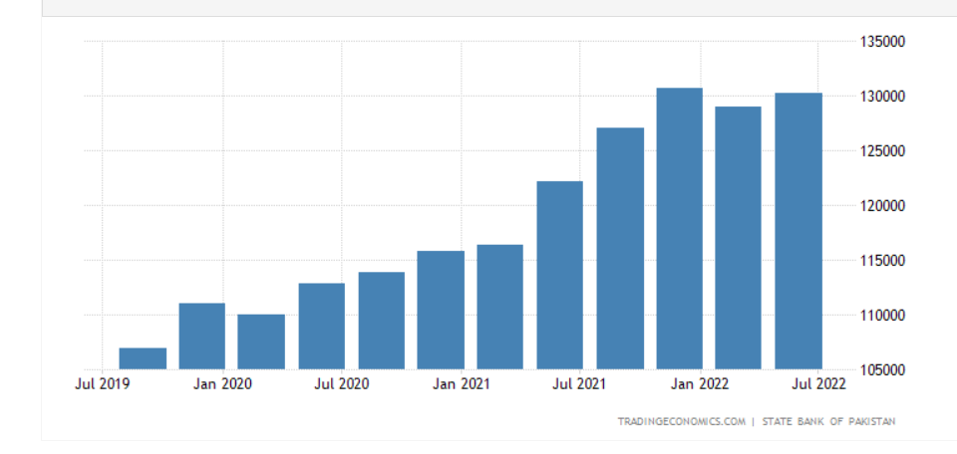

***As of 2022, Pakistan owns PKR 59.7 trillion in debt, equivalent to a staggering 89.2% of the country's GDP***.

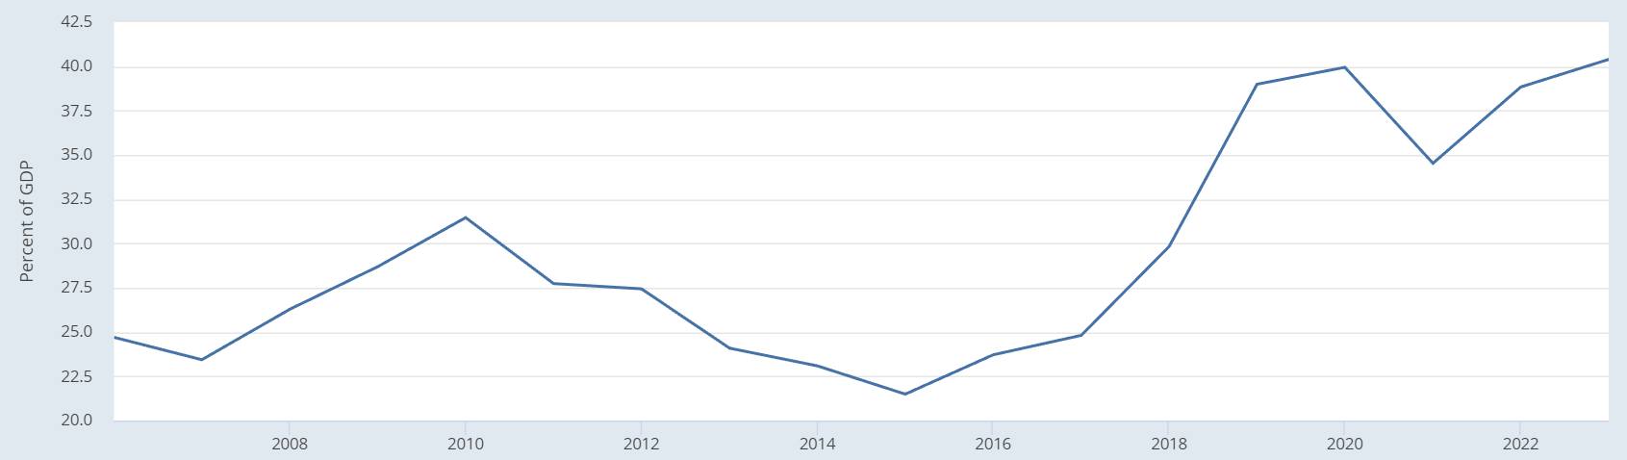

***Total External debt for Pakistan***

In addition, Pakistan's weak external position has further added to its economic struggles. Despite being removed from the FATF grey list in 2022 after an extended period of inclusion, Pakistan's global standing suffered due to the imposition of economic sanctions.

Another factor contributing to the crisis is the 2022 floods, which have caused extensive damage to critical infrastructure, impacted millions of people, and reduced domestic output by $3 billion approx. The floods have also exacerbated existing vulnerabilities and structural weaknesses in the economy, such as an inadequate supply chain, inadequate storage facilities, and distribution challenges. These issues have resulted in shortages and price increase of essential commodities, further adding to the economic crisis.

The Ukraine-Russia war has also had an impact on the Pakistan economy. Disruptions to the supply chain have led to shortages of essential goods, such as energy and fertilizer. This has further contributed to inflation and economic instability in the country.

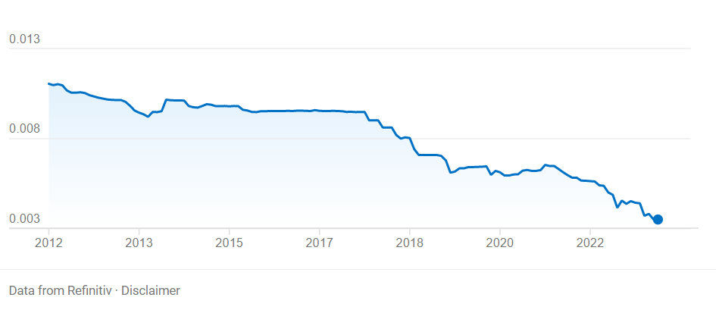

***Pakistan rupee is declining in value relative to the US dollar***.

The devalued currency is another factor contributing to the economic crisis in Pakistan. The Pakistan rupee has been depreciating rapidly, making imports increasingly expensive and leading to rising prices of essential commodities. Furthermore, the country's lack of technological advancements and land reforms in agriculture, with high costs of diesel, electricity, and fertilizers, have also contributed to inflation and reduced output.

Smuggling of wheat to Afghanistan has also led to local shortages and higher prices, further worsening the economic crisis. Additionally, the global rise in inflation has further worsened the situation in Pakistan, which has already been grappling with high inflation due to the floods and IMF conditions. The unstable government in Pakistan lead to an unfavourable business environment for companies, which discourage them from investing and building offices in the country. This result in a loss of potential economic opportunities and jobs for the people of Pakistan. A lack of stability can also lead to uncertainty in policies and regulations, which can create further obstacles in business environment for businesses operating in the country.

1. **Study of the role of international organizations in addressing the crisis**

As Pakistan seeks to access funding from the international lender to maintain its economy, the IMF has asked the Pakistan to protect the poor and impose higher taxes on the wealthy. In November 2022, the IMF refused to give a payment of $1.18 billion that was due to the Pakistan government because the government had not met certain demands. These demands included the government's commitment to increase energy rates, impose additional taxes, lowering subsidies, and refrain from artificially controlling the exchange rate. The IMF has repeatedly urged it to withdraw subsidies, particularly those for petrol. However, when Pakistan finally removed the petrol subsidy, it had a very negative impact on the country's petrol prices. Pakistan has received bailouts from the IMF 13 times in the past 35 years alone, and more will come in the future.

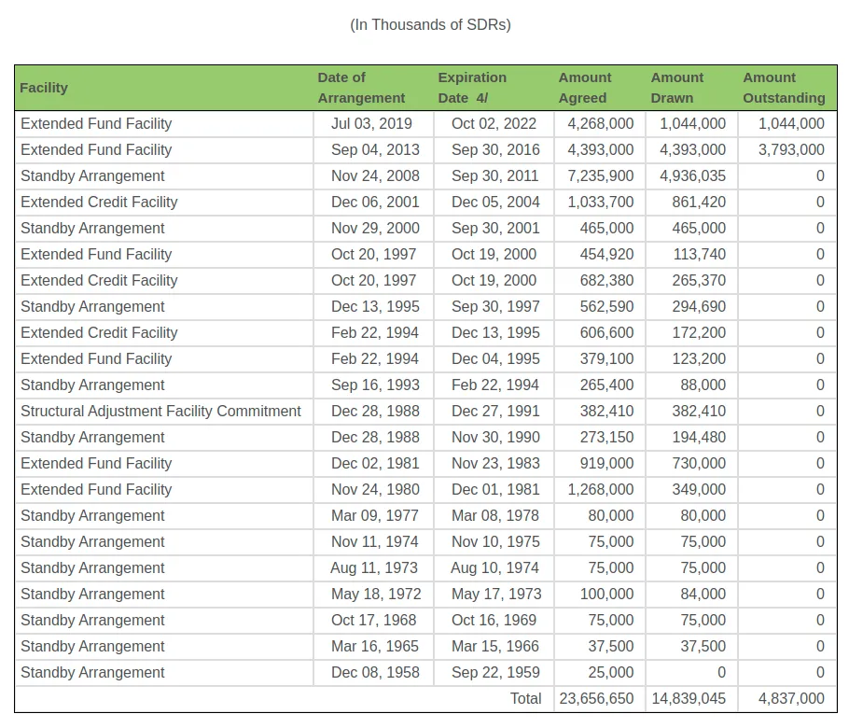

The US, France, Saudi Arabia, China, and Japan have all pledged financial support to Pakistan to date, and the Asian Development Bank and the Asian Infrastructure Investment Bank have also expressed interest in providing assistance to Pakistan.

The World Bank has been actively providing financial assistance to Pakistan for various development projects. In 2022, the World Bank approved new financing totalling $800 million to support critical power sector reforms and human capital development in Pakistan. The organization has also supported Pakistan's efforts to enhance property rights, improve access to affordable housing and mortgage finance for low-income households, and provide relief to flood-affected areas in Sindh through five projects with a total value of $1.692 billion. In addition, the World Bank has approved a $195 million loan to improve electricity supply and distribution for consumers in Pakistan. These initiatives highlight the World Bank's commitment to supporting Pakistan's socio-economic development and improving the lives of its people.

1. **Exploration of the impact of the crisis on the Pakistan’s population and other countries**

The people of Pakistan have been significantly impacted by the economic crisis. Many people find it difficult to afford basic essentials like food and medicine due to the over 10% increase in inflation. The price of things like petrol and electricity has increased as a result of the rising cost of imports, further worsening people’s condition. Businesses have also been impacted by the falling currency, finding it more challenging to import machinery and raw materials. In several sectors, this has resulted in decreased production and job losses. The economic and political crises in Pakistan have also affected the recovery efforts like the floods that occurred last year. The disaster affected roughly one-third of Pakistan's landmass and impacted millions of its poor citizens. While climate change driven by wealthy countries can be partially blamed for the disaster, international aid has been slow and insufficient. As a result, Pakistan has largely been left to deal with the aftermath on its own.

Due to Pakistan's serious economic problems, India might be faced with more Chinese influence in both Pakistan and the larger South Asian area. Historically, when the US used Pakistan as a pawn in its struggle with the Soviet Union, certain segments of Pakistan's ruling elite were hostile against India. There is low trade volume between two countries, so it will not have any noticeable impact on Pakistan economy.

The economic crisis in Pakistan has not only affected its own economy but has also had a significant impact on the trade relationship between Pakistan and Afghanistan. The volume of goods traded between the two countries has dropped which has resulted in the devaluation of the Pakistan rupee. This has made Pakistan goods more expensive for Afghan traders to buy, leading to a decline in trade. The lack of trade has also affected the Afghan economy, as it is heavily dependent on imports from Pakistan. Additionally, the closure of the Torkham border crossing between the two countries due to Covid-19 restrictions has further worsened the situation, leading to a rise in smuggling and illegal trade.

1. **Comparative analysis of Pakistan's economic crisis with other countries**

The world community thinks that Pakistan is imitating Sri Lanka because of Pakistan's huge loss in foreign exchange reserves and its ongoing political instability. Pakistan and Sri Lanka share several similarities in their economic situations. Both countries are burdened with high levels of debt and have fallen into China's debt trap. Both nations have invested lot of time in providing subsidies to their citizens despite of so much loan. They both relied heavily on remittances and have a limited manufacturing base, which leads to fewer exports with low added value. The countries also share a history of political instability, including popular political tactics and a colonial institutional framework. Pakistan's history of sponsoring terrorism and extremist ideologies poses a risk also of the country becoming an Afghanistan rather than facing an economic collapse similar to Sri Lanka's. Egypt, similar to Pakistan, has received substantial loans and investments from China and has been trying to secure an International Monetary Fund bailout. Despite the situation seems like Sri Lanka, some economists argue that due to their large militaries and populations exceeding 330 million, Egypt and Pakistan are too big to be allowed to go down by their economic and political partners, which include the IMF, its G7 supporters, the oil-rich Gulf Arab states, and China. El Salvador successfully made a $600 million bond payment however; the country still has around $6.4 billion in outstanding Eurobonds. Despite the next payment not being due until 2025, there are concerns about the country's high debt service costs, financing plans, and fiscal policies, which have led to its bonds being considered deeply distressed. Ghana, Lebanon, Tunisia, and Zambia are among the countries currently facing or at risk of an economic crisis due to their high levels of debt.

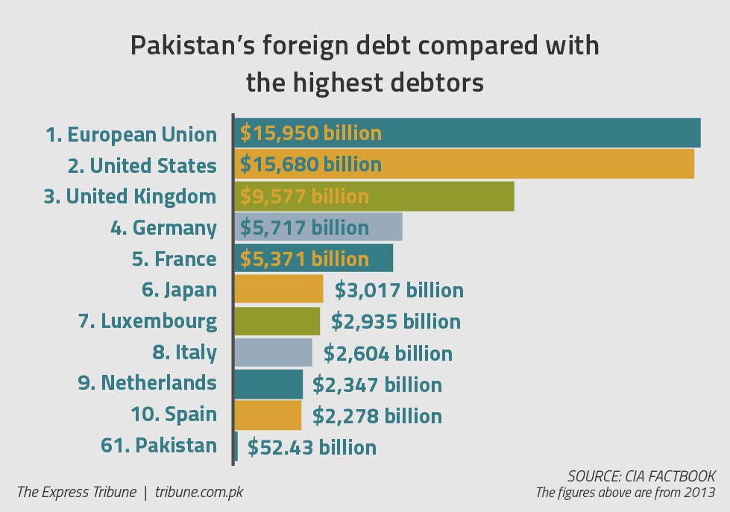

|  |  |  |  |  |  |
| --- | --- | --- | --- | --- | --- |
| **RANK** | **COUNTRY/**  **REGION** | **EXTERNAL DEBT (US DOLLARS)** | **DATE** | **PER CAPITA (US DOLLARS)** | **PERCENTAGE OF GDP** |
| 1 | United States | 31 trillion | Jan 2023 | 94,188.00 | 121.08 |
| 2 | United Kingdom | 8.73 trillion | June 2022 | 129,203.00 | 273.06 |
| 3 | France | 7.04 trillion | June 2022 | 107,245.00 | 253.35 |
| 4 | Germany | 6.46 trillion | June2022 | 77,607.00 | 160.35 |
| 5 | Japan | 4.36 trillion | June 2022 | 34,841.00 | 101.41 |
| 6 | China | 2.64 trillion | June 2022 | 1,866.00 | 14.39 |
| 7 | Italy | 2.51 trillion | 31 Dec 2017 | 42,300.00 | 141.00 |
| 8 | Spain | 2.26 trillion | 31 Dec  2017 | 48,700.00 | 170.00 |
| 9 | Canada | 3.2 trillion | 31 Dec  2017 | 52,300.00 | 143.00 |
| 10 | Australia | 1.83 trillion | 31 Sept 2020 | 71,906.00 | 130.00 |
| 47 | Pakistan | 122 billion | 30 Sept 2021 | 554.00 | 43.00 |

***List of countries with respect to external debt***

Pakistan rank is 47th in this table which shows its external debt is low. But this does not indicate that Pakistan's financial situation is stable, nor does it imply that there is nothing to be concerned about. Unlike some other countries, Pakistan is not a net creditor and cannot rely on the same system that other countries use to manage their finances.

If a country fails to repay its debts, it goes into default, as has occurred with countries like Argentina, Greece, and Zimbabwe in recent years. Pakistan has come close to defaulting several times, but it has managed to avoid it by securing last-minute emergency loans. However, Pakistan's reliance on foreign loans has created a "debt trap," in which it must borrow more money just to pay off the loans it already owes.

Globally, nations are heading towards a debt crisis. Inflation, high debts and economic slowdowns have made it nearly impossible for many governments to repay their debts. Normally, those nations could just add new debt to pay off the previous debt. However, the present condition around the world has made it much harder to do so.

1. **Conclusion**

After conducting extensive research, it is evident that several countries, including Pakistan, are facing severe economic crises due to factors such as high debts, political instability, corruption, and natural disasters. Other countries such as Sri Lanka, Egypt, Ghana, Lebanon, Tunisia, and Zambia are also facing economic challenges, but each country has some unique cause contributing to their crises. Pakistan's economic crisis is not just a concern for the country itself but also for the world. As a nuclear-powered country, its failure could have severe consequences, especially if nuclear power come into the hands of terrorists.

Despite the challenges, international organizations like the IMF and the World Bank have attempted to assist Pakistan in solving its economic crisis. However, the people of Pakistan continue to suffer from the crisis and the resulting inflation of prices.

Nevertheless, there are still opportunities for Pakistan to address its economic and political issues, implement reforms, and work with international partners to secure sustainable solutions and some loans. This will not only help Pakistan economy and its population condition but also contribute to regional stability and security.

# **References**

1. (n.d.). Retrieved from The World Bank: https://www.worldbank.org/en/home
2. *https://byjus.com/free-ias-prep/pakistan-economic-crisis-upsc-notes/*. (n.d.). Retrieved from BYJU'S EXAM PREP: https://byjus.com/free-ias-prep/pakistan-economic-crisis-upsc-notes/
3. Hussain, M. (2023, 2 12). *Pakistan on the Brink: What the Collapse of the Nuclear-Armed Regional Power Could Mean for the World*. Retrieved from The Intercept: https://theintercept.com/2023/02/12/pakistan-economy-crisis-imf/
4. Hussain, T. (2023, 2 5). *Why Pakistan and Egypt are too big to fail to a Sri Lanka-style economic crisis*. Retrieved from South China Morning Post: https://www.scmp.com/week-asia/economics/article/3208998/why-pakistan-and-egypt-are-too-big-fail-sri-lanka-style-economic-crisis
5. *List of countries by external debt*. (2013, 4 16). Retrieved from Wikipedia: https://en.wikipedia.org/wiki/List_of_countries_by_external_debt#References
6. Nayan. (2023, 1 6). *Pakistan’s Economic Crisis (2022) – A Case Study & Analysis*. Retrieved from Aayush Bhaska: https://aayushbhaskar.com/pakistan-economy-analysis/
7. *Pakistan economic crisis impacting Kabul-Islamabad trade*. (2023, 3 4). Retrieved from theprint: https://theprint.in/world/pakistan-economic-crisis-impacting-kabul-islamabad-trade/1418772/
8. *Pakistan, Egypt and other developing countries facing a debt crisis*. (2023, 4 6). Retrieved from Arab News Pakistan : https://www.arabnews.pk/node/2282186/business
9. Qadri, H. M.-u.-D. (2023, 4 20). *The economic woes of Pakistan and Sri Lanka have similar origin stories*. Retrieved from Scroll: https://scroll.in/article/1043775/the-economic-woes-of-pakistan-and-sri-lanka-have-similar-origin-stories
10. Shikre, R. (2022, 10 6). *Economic Crisis in Pakistan: 4 Major Reasons contributed to it*. Retrieved from Economy Simplified: https://economysimplified.com/economic-crisis-in-pakistan/
11. Siddiqui, S. S. (n.d.). *The Express Tribune explains foreign debt*. Retrieved from Tribune : http://labs.tribune.com.pk/the-express-tribune-explains-foreign-debt/
12. Singh, J. (2023, 1 11). *How Will Economic Crisis In Pakistan Impact Its Neighbours?* Retrieved from adda247: https://www.adda247.com/upsc-exam/how-will-economic-crisis-in-pakistan-impact-its-neighbours/
13. *Total External Debt for Pakistan* . (2022, 10 31). Retrieved from Economic Research Federal Reserve Bank of India: https://fred.stlouisfed.org/series/PAKDGDPGDPPT